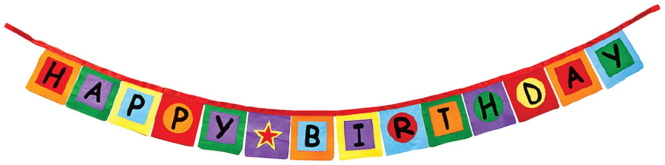

Celebrating Birthdays in Kindergarten!

Birthdays are a special time for children and we look forward to celebrating with your child!

On your child’s birthday, you are invited to send in a favorite treat for the class. Please notify us of your intentions at least one day in advance, so that we can be sure to allow time for these treats during our day (most likely during our daily snack time or as an after-lunch treat). Small sized treats tend to work best for kindergarten consumption

Special note about birthday parties: Party invitations may not be given out in the classroom unless the entire class is invited. Thank you for your understanding.

