Classroom Management in Mrs. Bardzik’s Class

The kindergarten classes will participate in the school-wide PBIS behavior management program in which positive behavior will be recognized and rewarded through our “feather system” (bulletin board located in classroom).
​
In addition, we use a rule-specific behavior management plan in the classroom. Our class rules are as follows:

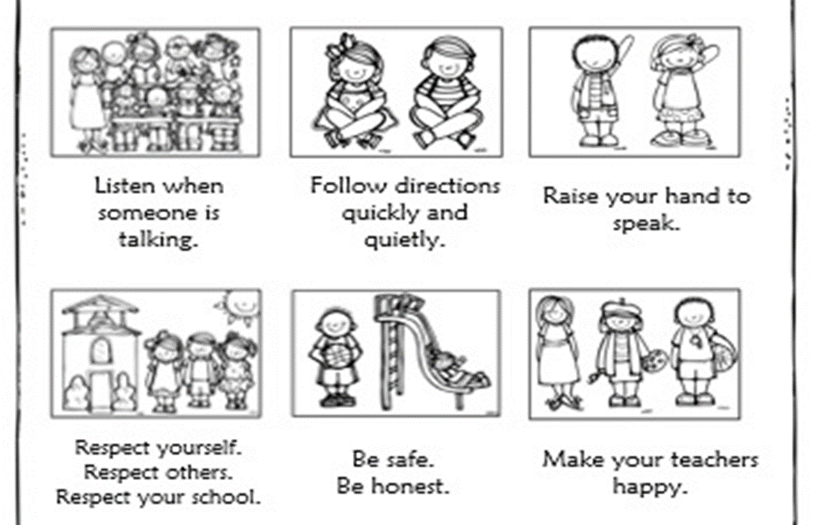
K-B Classroom Rules

The rules are posted in the classroom and as part of our daily morning routine, we recite the rules as a class. Throughout the day, if a child is having a problem with a specific rule, they are given a warning that they are not honoring that specific rule. They are warned that if the behavior continues, it will result in a teacher-student "conference". During a teacher-student "conference", the student and teacher go over the difficulty that the student was having and the child is encouraged to articulate which classroom rule was not honored. A conference record sheet is then signed by the teacher and student and sent home as a communication tool for the parents. Parents are asked to discuss and sign the conference sheet before returning it to school.

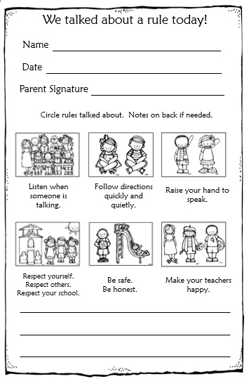

The goal of the program is to encourage children to be responsible for their behavior choices and to provide open lines of communication between home and school about any areas of routine that the child may be struggling with.

